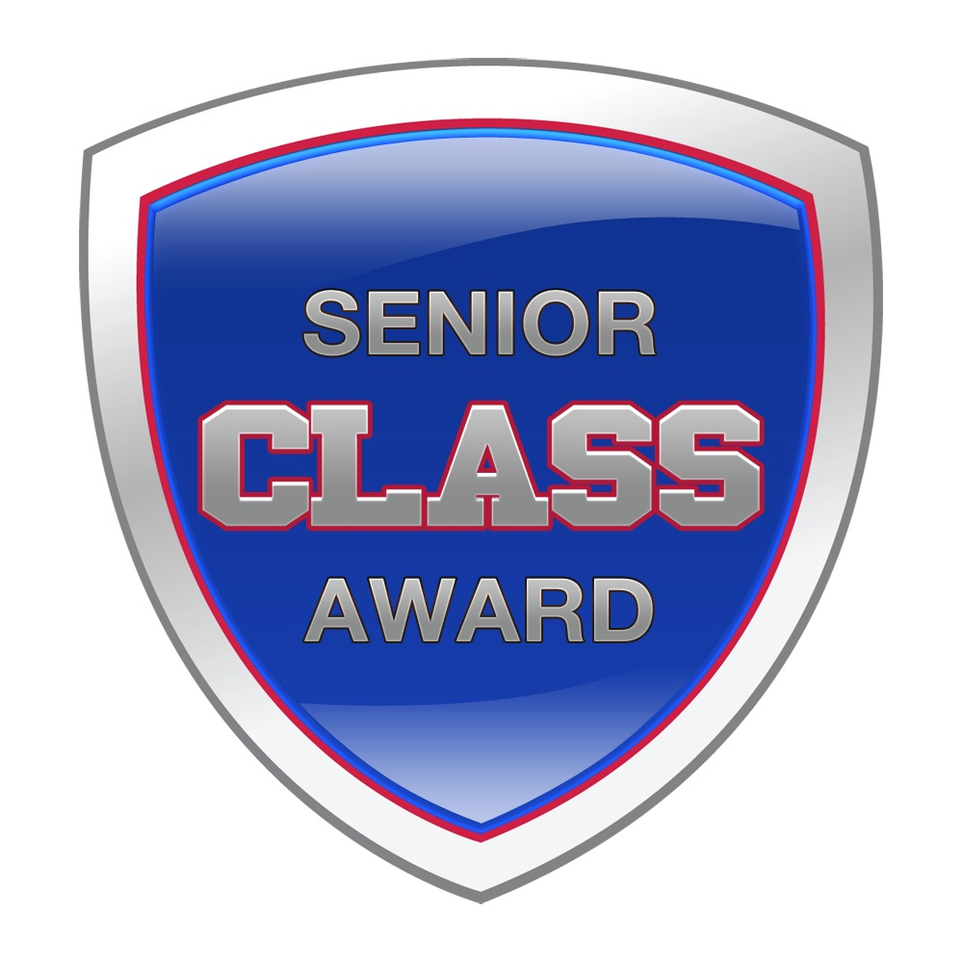

FOR IMMEDIATE RELEASE

Ohio State University’s Zach Mason Wins the 2015 Senior CLASS Award® for Men’s Soccer
With Mason’s win, Ohio State becomes the first university to produce back-to-back Senior CLASS Award winners in the same sport.

OVERLAND PARK, Kan. (December 10, 2015) – Ohio State standout Zach Mason has been selected through nationwide balloting as the 2015 Senior CLASS Award® winner in NCAA® Division I men’s soccer becoming the second Buckeye in as many years to receive the award. Mason follows 2014 winner Alex Ivanov as the second consecutive Buckeye to win the Senior CLASS Award for men’s soccer, marking the first time since the 2001 inception of the award that student-athletes from the same university have earned back-to-back awards in the same sport.

“It’s amazing to be the first team to win this award two years in a row,” said Mason, the 18th Senior CLASS Award winner from the Big Ten Conference. “Ivy (Alex Ivanov) set a great example for me to follow, and I tried to continue his legacy. It’s a testament to the high standards of Ohio State Athletics.”

An acronym for Celebrating Loyalty and Achievement for Staying in School®, the Senior CLASS Award focuses on the total student-athlete in 10 NCAA sports and encourages students to use their platform in athletics to make a positive impact as leaders in their communities. To be eligible for the award, a student-athlete must be classified as an NCAA Division I senior and have notable achievements in four areas of excellence: classroom, community, character and competition. The award for men’s soccer is chosen by a vote of Division I men’s soccer coaches, national soccer media and fans and is given annually to the most outstanding senior student-athlete in Division I men’s soccer.

“I am extremely humbled and happy to receive this award, and I'd like to dedicate it to my grandfather Timothy Boylan, who recently passed away,” said Mason. “Being a student-athlete at The Ohio State University has been one of the greatest experiences of my life. I've learned so much about myself and grown tremendously over these past four years. I've learned the importance of commitment and persistence, two values I will carry with me into the next chapter in my life. I’ve felt so much support from countless individuals and the entire Buckeye community, as well. This award is a win not just for me, but for all of Ohio State."

As a standout midfielder and two-time team captain, Mason guided the Buckeyes to their school’s fourth NCAA Sweet 16 appearance, a program-record 10 home wins and an eight-match win streak in 2015. Never missing a start in his four years at OSU, Mason earned Big Ten All-Tournament Team honors this season after being part of a defensive unit that earned 10 clean sheets this season to lead the Big Ten.

Off the pitch, Mason also dedicated himself to classroom and community success. En route to a bachelor’s degree in operations management, Mason has earned two Academic All-Big Ten honors, two Big Ten Distinguished Scholar nods and one NSCAA All-East Scholar recognition. He also participated in the 2015 Buckeye Go Pro Summer Internship program as a way of developing his professional leadership and career skills.

“I’m extremely proud of Zach and very happy for him and his family,” said Ohio State Head Coach John Bluem. “He is certainly deserving of this honor. On and off the field, his commitment to excellence, his leadership qualities and his incredible work ethic are unsurpassed.”

Mason’s top-tier reputation extends beyond the Ohio State athletic department, as well, where he has established himself as one of the most dedicated and responsible athletes throughout the conference. Named the Big Ten Sportsmanship Award winner in 2014, the 5’9” Galena, Ohio, native is known as a tremendous leader who exemplifies the best qualities of a student-athlete and has a positive influence on his teammates. Also demonstrating a genuine concern for those in the community, Mason has served with Meals on Wheels, Habitat for Humanity and with local youth soccer teams.

With this honor, Mason becomes the third Ohio State student-athlete to be honored as a Senior CLASS Award winner behind Ivanov and James Laurinaitis, who was voted as the football award winner in 2008.

“We’re thrilled that Zach Mason has won this year’s Senior CLASS Award,” said Erik Miner, executive director for the Senior CLASS Award. “Not only is this a testament to Zach’s tremendous character and skill, but also to the entire Ohio State athletic department for helping develop such quality young men and women year after year. Our congratulations go out to Zach, his family, his team and the entire university.”

For more information, visit seniorCLASSaward.com.

# # # #
First-Team Senior All-Americans
Amass Amankona, Dayton
Jack Gorab, Brown
Jesse Klug, Bucknell
Zach Mason, Ohio State
Matt Pacifici, Davidson

Second-Team Senior All-Americans
Jonathan Campbell, North Carolina
Mike Casey, Rhode Island
Jamie Merriam, West Virginia
Chase Minter, Cal Poly
Brandon Vincent, Stanford

CONTACT
Erik Miner
Phone: (913) 563-5412
eminer@seniorCLASSaward.com

ABOUT THE AWARD
An acronym for Celebrating Loyalty and Achievement for Staying in School, the Senior CLASS Award honors the attributes of senior student-athletes in four areas: community, classroom, character and competition. The award program is designed exclusively for college seniors who are utilizing their complete athletic eligibility, remaining committed to their university and pursuing the many rewards a senior season can bring. Premier Sports Management manages the award.

NCAA and College Cup are trademarks owned or licensed by the National Collegiate Athletic Association.

