FOR IMMEDIATE RELEASE

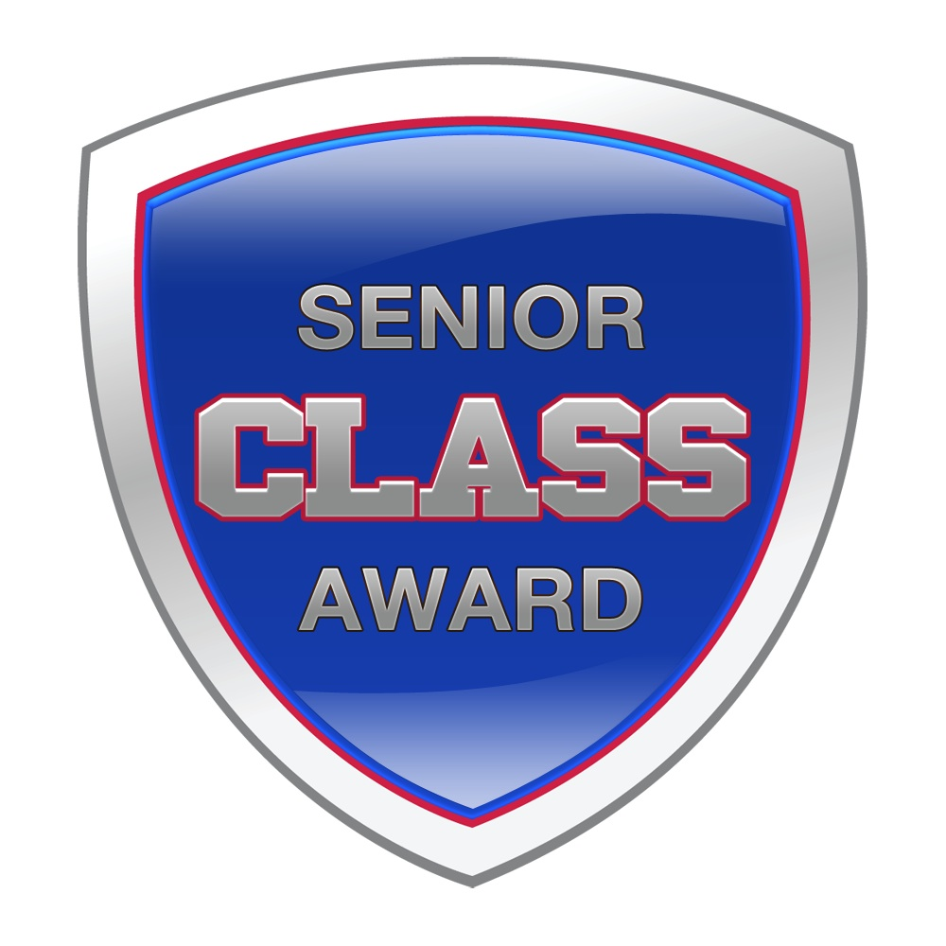
Men’s and Women’s Soccer Candidates Announced for the 2016 Senior CLASS Award

OVERLAND PARK, Kan. (October 4, 2016) – Sixty NCAA® men’s and women’s soccer student-athletes who excel both on and off the field were selected as candidates today for the 2016 Senior CLASS Award® in collegiate soccer. To be eligible for the award, a student-athlete must be classified as an NCAA Division I senior and have notable achievements in four areas of excellence: community, classroom, character and competition. The complete list of candidates follows this release.

An acronym for Celebrating Loyalty and Achievement for Staying in School®, the Senior CLASS Award focuses on the total student-athlete and encourages students to use their platform in athletics to make a positive impact as leaders in their communities.

Of the 60 candidates, 29 have grade-point averages of 3.5 or higher, 13 are returning All-Americans and 12 are on the preseason watch list for the Missouri Athletic Club’s Hermann Trophy, which recognizes the top player in collegiate soccer. Outside of academics and athletics, all candidates also have been consistently involved in community service on their campus or in their communities.

Each of the two candidate classes will be narrowed to 10 finalists midway through the regular season, and those 10 names will be placed on the official ballot. Ballots will be distributed through a nationwide voting system to media, coaches and fans, who will select one male candidate and one female candidate who best exemplifies excellence in the four Cs of community, classroom, character and competition.

The Senior CLASS Award winners will be announced during the 2016 NCAA Men’s and Women’s College Cup® championships in December.

For more information on all the candidates, visit seniorCLASSaward.com.
# # # #

Men's Soccer Candidates
Lalas Abubakar, Dayton | Sergio Manesio, Cleveland State
Oyvind Alseth, Syracuse | Simon Megally, DePaul
Michael Amick, UCLA | Skyler Milne, Utah Valley
Brandt Bronico, Charlotte | Tyler Moorman, Detroit Mercy
Udi Cohen, Hartford | Mark Moulton, Omaha
Paddy Foss, Virginia | Brian Nana-Sinkam, Stanford
David Goldsmith, Butler | Alex Neff, Utah Valley
Sam Hamilton, Denver | Colin O’Neil, Colgate
Ian Harkes, Wake Forest | Brad Ruhaak, Akron
Jacori Hayes, Wake Forest | Carlos Ruiz, UMass Lowell
Joseph Holland, Hofstra | Ben Sampson, Delaware
Danny Jensen, Ohio State | Tanner Thompson, Indiana
Daniel Johnson, Louisville | Chris Wingate, New Hampshire
Tyler Kidwell, Ohio State | Phil Woods, Missouri State
Darrin MacLeod, Drake | Justin Worley, Lehigh

Women's Soccer Candidates
Maddie Bauer, Stanford | Simone Kolander, Minnesota
Jenny Bitzer, Manhattan | Ashley Lawrence, West Virginia
Rachel Bloznalis, Boston University | Rose Lavelle, Wisconsin
Kadeisha Buchanan, West Virginia | Clara Logsdon, William & Mary
Kristen Crowley, Florida State | Paige Lombard, Pennsylvania
Courtney Dike, Oklahoma State | Leah Mattingly, Ball State
Mackenzie Dowd, Northeastern | Sarah Grace Nicholson, Drake
Natalie Fenske, North Dakota State | Morgan Proffitt, Marquette
Mandy Freeman, USC | Casie Ramsier, Auburn
Christina Gibbons, Duke | Alexa Schneider, Albany
Meggie Dougherty Howard, Florida | Julie Spracklin, Monmouth
Darian Jenkins, UCLA | Morgan Stearns, Virginia
Abby Jones, Clemson | Murielle Tiernan, Virginia Tech
Savannah Jordan, Florida | Tabitha Tindell, Florida Gulf Coast
Serina Kashimoto, Butler | Koree Willer, Iowa State

CONTACT
Erik Miner
Phone: 913-563-5412
eminer@seniorCLASSaward.com

ABOUT THE AWARD
An acronym for Celebrating Loyalty and Achievement for Staying in School, the Senior CLASS Award honors the attributes of senior student-athletes in four areas: community, classroom, character and competition. The award program is designed exclusively for college seniors who are utilizing their complete athletic eligibility, remaining committed to their university and pursuing the many rewards a senior season can bring. Premier Sports Management manages the award.

*NCAA and College Cup are trademarks owned or licensed by the National Collegiate Athletic Association.

